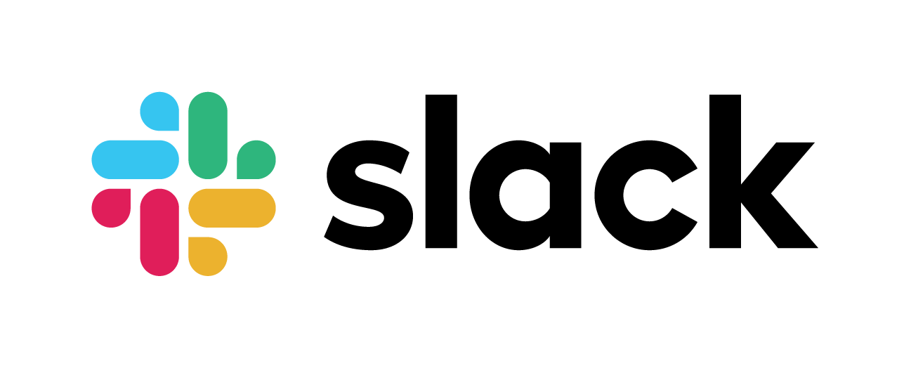

Exchange Currency Documentation



Mabel Montano

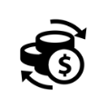 About …

The purpose of this project to have on hand the current exchange rate. Asking **@currency** the exchange from USD to CAD. This project is develop in go language, using the Slack API to integrate and Currency stack API to get the result.

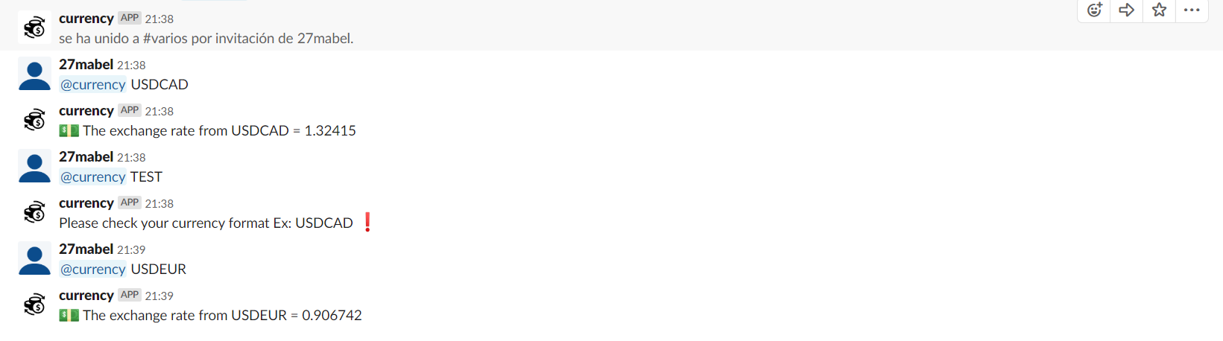Example

 STEP 1: SET UP SLACK- Create the bot user.

**Name of the bot:** currency

**Image:** currency.png (inside the img folder)

**Background color:** #1d7c00

**Note: Save the Bot User OAuth Access Token**

 STEP 2: CLONE - Clone the project from the repository.

<https://github.com/mabel27/MyGoProject>

 STEP 3: BATCH FILE – Run the batch file.

 STEP 4: RUN THE APP- Running the src.exe

* Change the directory to C:\Project\myExchangeProject\src>
* Run go build
* Run src.exe